PART 3 IMPROVEMENTS:

* I Added a live clock date and time display at the top right of every page.
* I Included a newsletter subscription option on the Home and Contact pages.
* Created a new Cart page that displays items added from the product section.
* In the product section i added a "Ready to Find Your Perfect Piece?" area that links to the Contact and Gallery pages to help users decide or get inspired.
* Added a Clear Cart button that removes all items from the cart or lets users remove specific ones.
* Included toast notifications when items are added to or removed from the cart.
* I Improved the navigation area by adding spacing and a line separator to make it more organized and easier to read.
* I arranged gallery images neatly with spacing and labeled each picture with a clear name below it.
* For gallery page I made the gallery images open in fullscreen.

**JAVA SCRIPT SECTION:**

**What I added in the java script:**

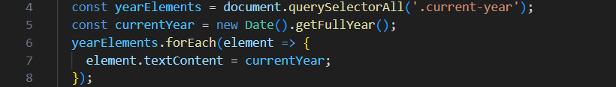

I added a script that automatically shows the current year in the footer, so it updates itself every year without needing manual changes.

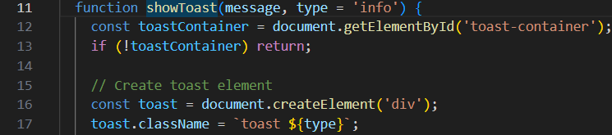

I made a toast notification system that shows little pop up messages when users do things like add a product to their cart, take items out or send a form. It uses different icons and colors to show if something is successful if there's an error or if it's just information.

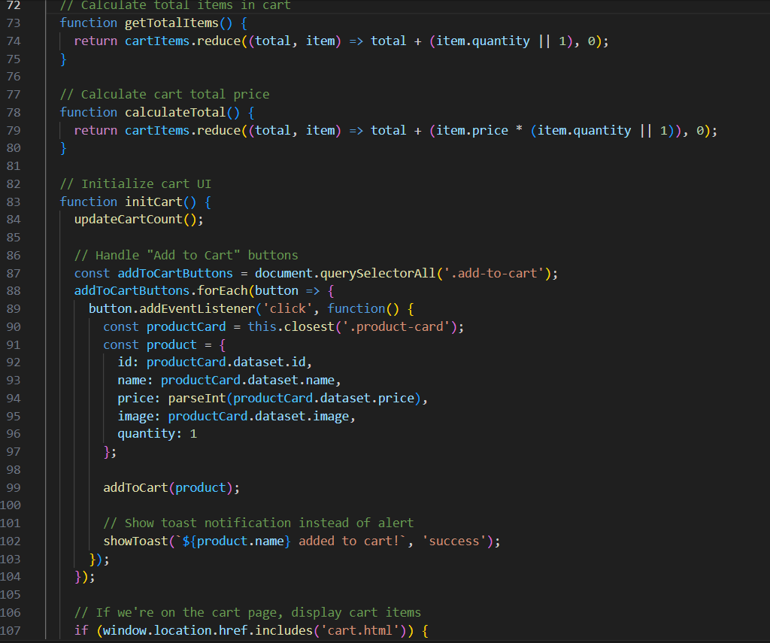

I added a full shopping cart system that allows users to add products, change the quatity of cart items, take items out ,see the total cost and empty the whole cart. The cart information is stored in LocalStorage so it remains even the page is refreshed and the of items is shown live on the webite.



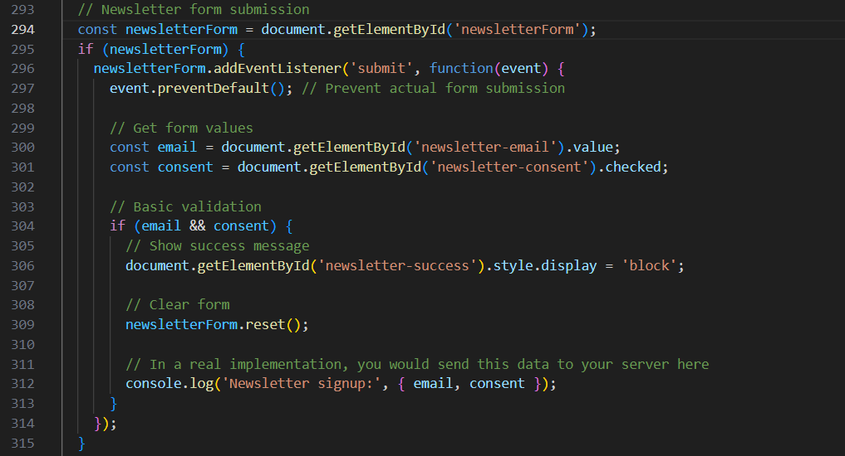

I created a simple newsletter form that verifies if the user has entered an email and provided consent. When the form is submitted it displays a success message and clears the form.

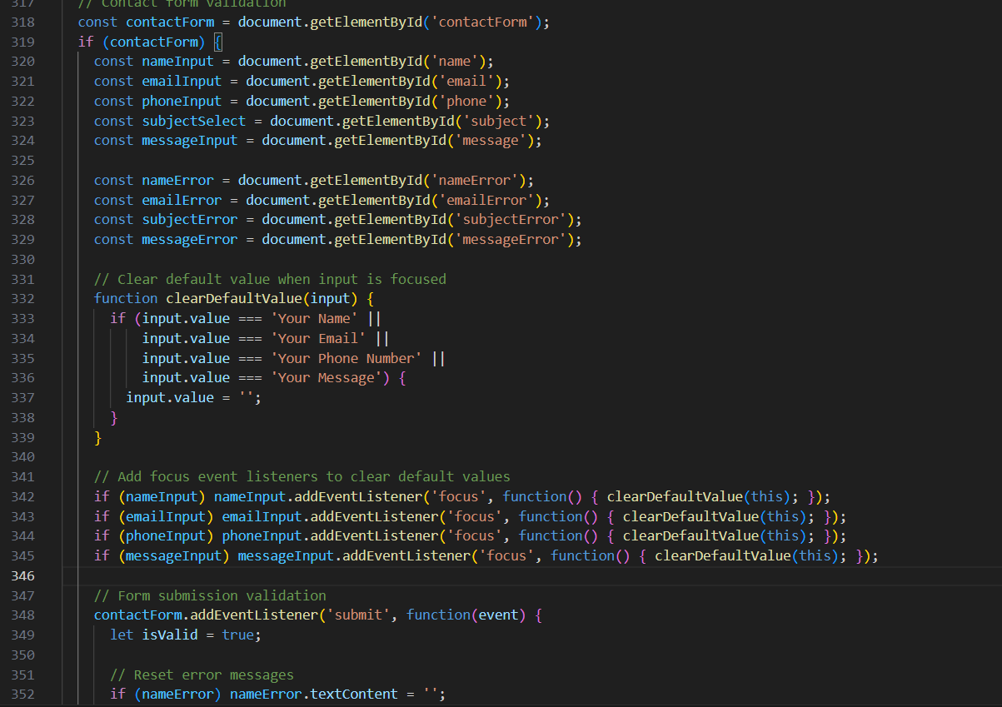

I added validation for the contact form to ensure that users enter their name, email, subject and message properly. It shows useful error messages if anything is missing or not correct.

6.

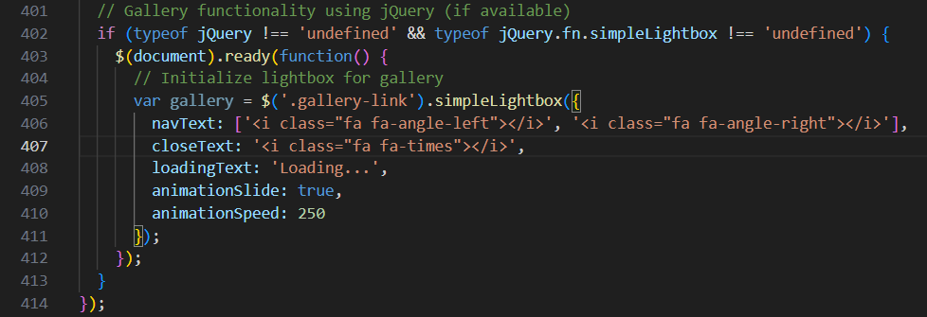

I used a lightbox plugin so that when you click on the gallery images they open in fullscreen. It has smooth animations too

7.

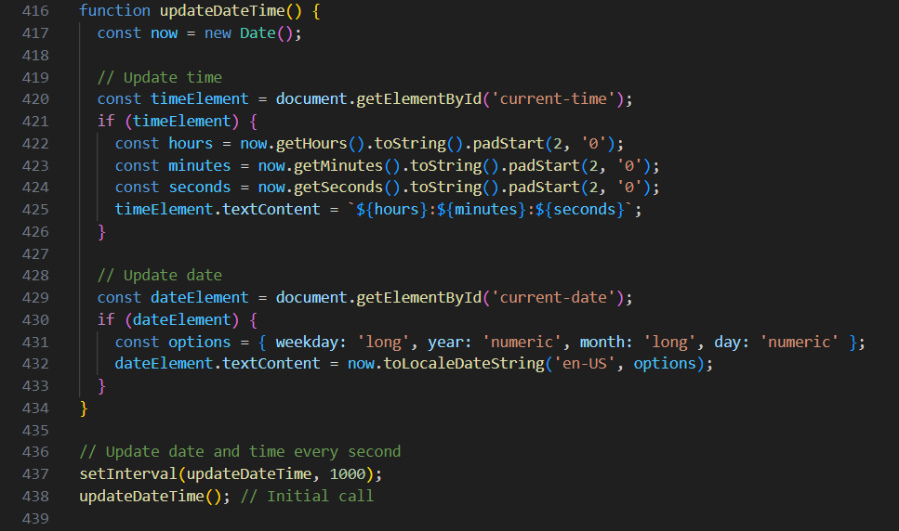

I added a live clock that shows the current time and date on the website, and it updates every second in real time.

**SEO**

1. **HOMEPAGE**

* I included a meta description in the head section that gives a short summary of the homepage content: "Jewels of Joy offers exquisite handcrafted jewelry including rings, necklaces, bracelets, and earrings. Discover elegant pieces made with quality craftsmanship." This helps improve how the page appears in search results.
* I put detailed alt text for each image such as "Elegant gold necklace with minimalist pendant design" and "Minimalist silver band ring for everyday wear" so that search engines can figure out what the images are about and users can still know what they are looking at if the pictures don’t show up.
* I used relevant keywords throughout the page such as "handmade jewelry," "necklaces," "bracelets," "rings" and "South Africa" to improve visibility when users search for similar products online.

1. **ABOUT PAGE**

* I added a meta tag in the head section to provide a short summary of the page’s content. This includes: “Learn about Jewels of Joy, our story, values and the passionate team behind our handcrafted jewelry collections. Discover what makes our jewelry special.” This helps with visibility on search engines.
* I made sure that all my content was correctly structured with headings like OUR STORY, OUR VALUES and MEET OUR TEAM to improve readability and user experience.
* I included keywords such as Jewels of Joy, handmade jewelry, South Africa jewelry, and jewelry values to help improve SEO and make the page easier to find online.

1. **PRODUCTS**

* I included relevant keywords such as handmade jewelry, affordable luxury, necklaces, bracelets and Jewels of Joy in both the meta tags and visible content to increase my search engine ranking.
* I made sure that all my content was properly structured using clear headings (<h1>, <h3>, <p>) .
* added alt attributes for all my product images so that search engines can understand what each image is about.

1. **Contact**

* I made sure the layout is neat and easy to read for a better user experience.
* I added a brand heading, slogan and logo at the top of the page for clear identity.

1. **Gallery**

* Added alt text to all the images to help search engines understand image content.
* Added a <meta name="description"> tag to describe the page content for search engines.
* Added a <meta name="keywords"> tag with relevant keywords like "handmade jewelry," "necklaces," "rings," and "Jewels of Joy."

1. **Cart**

* Here no SEO changes were made as this page’s purpose is to only function as a shopping cart where you can see the items you’ve chosen.